
Supporting: MSAOHS200A Work safely

Section 2 Assignment: Managing risks
Name |  | Date
Your task is to carry out a risk assessment in your workplace. You may choose:
- a particular machine that you work with or are planning to work with
- a work process that you regularly undertake.
For each of the hazards you identify:
- describe the tasks where they occur
- rate the risk of injury or illness from 1 to 6, using the Risk Assessment Table shown earlier in Assessing risks.
- suggest practical control measures that would minimise the risks, in keeping with the risk rating you have given the hazard. Use the ‘Hierarchy of controls’ shown on the Controlling risks page.

Equipment or work process being assessed

This Risk Assessment form is based on the WorkCover risk assessment template in the publication: Hazpak – making your workplace safer. The risk rating system used in this form is also described in more detail in the Hazpak document.
The publication can be downloaded as a PDF from the NSW WorkCover website.

1. Pinch points and crush injuries
A. Are there any exposed or unguarded moving parts (such as gears, drive shafts, rollers, chains, sprockets, wheels) which may catch clothing or body parts? |  | Yes  No | ❑   | 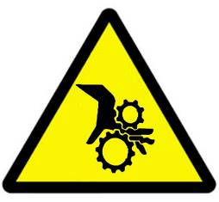
Tasks | Risk | Suggested controls

B. Can anyone be crushed due to:  - falling material, unexpected movement of the equipment or its load, or the equipment tipping over?  - being thrown off or under the equipment, or being trapped between the equipment and other structures? |  | Yes  No | ❑   | 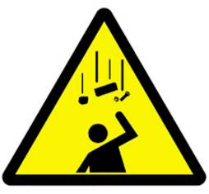
Tasks | Risk | Suggested controls

2. Cuts, punctures or strikes
A. Can anyone be cut, punctured or struck from:  - coming into contact with sharp objects or surfaces or moving parts?  - work pieces or materials being ejected, or parts of the equipment disintegrating? |  | Yes  No | ❑   | 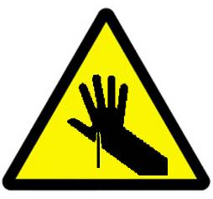
Tasks | Risk | Suggested controls

3. Hydraulic or pneumatic leaks
A. Can anyone come into contact with hydraulic fluid or compressed air due to:  - equipment failure or misuse?  - any other factors? |  | Yes  No | ❑   | 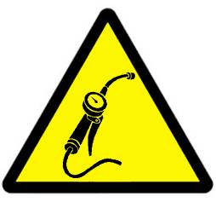
Tasks | Risk | Suggested controls

4. Electrical
A. Can anyone suffer electric shock from:  - exposed live contacts, or the presence of water or other conducting material?  - overloading of electrical circuits (including over-use of power boards)?  - damaged electrical leads, cables, switches, plugs or power points? |  | Yes  No | ❑   | 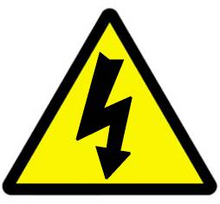
Tasks | Risk | Suggested controls

5. Manual handling and ergonomics
A. Will anyone be exposed to muscle strain, sprain or back injury from:  - bending forwards, sideways or twisting, especially if movements are combined  - sudden or jerky movements, or lifting loads unevenly or to one side?  - lifting, pushing or pulling heavy loads? |  | Yes  No | ❑   | 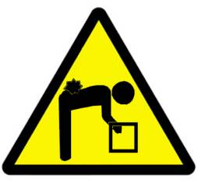
Tasks | Risk | Suggested controls

B. Will anyone be exposed to muscle strain, sprain or back injury from:  - handling objects that are too heavy without having help available?  - working in cramped or awkward spaces, or on uneven ground or slippery floors?  - reaching above shoulder height or below knee level |  | Yes  No | ❑  
Tasks | Risk | Suggested controls

C. Will anyone be exposed to muscle strain, sprain or back injury from:  - vibrations or jarring?  - moving materials over a long distance or handling loads that can’t be held close?  - staying in one position, especially bent, or carrying out fast repetitive actions? |  | Yes  No | ❑  
Tasks | Risk | Suggested controls

6. Controls and isolation
A. Are any controls not clearly marked, or out of easy reach of operators? |  | Yes  No | ❑   | 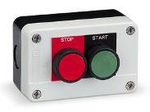
Tasks | Risk | Suggested controls

B. Is there any problem in isolating the equipment from all sources of energy (such as through tagging out or locking out)? |  | Yes  No | ❑   | 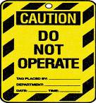
Tasks | Risk | Suggested controls

7. Slips and falls
A. Can anyone fall from a height (such as from a lack of guardrails or fallback cages)? |  | Yes  No | ❑   | 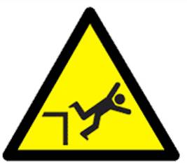
Tasks | Risk | Suggested controls

B. Can anyone be exposed to trip or slip hazards from parts, fittings, surfaces, floors or substances? |  | Yes  No | ❑   | 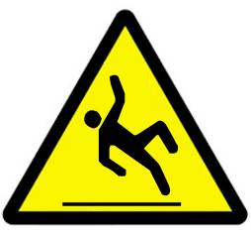
Tasks | Risk | Suggested controls

8. Personal protective equipment
A. Does the activity require the use of a dust mask or respirator? |  | Yes  No | ❑   | 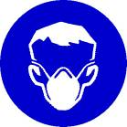
Tasks | Risk | Suggested controls

B. Does the equipment operate in a high noise area or at a noise level that may require the use of hearing protection? |  | Yes  No | ❑   | 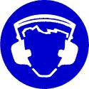
Tasks | Risk | Suggested controls

C. Will anyone be exposed to flying particles that may require the use of eye protection? |  | Yes  No | ❑   | 
Tasks | Risk | Suggested controls

D. Do operators need any other items of PPE (such as high visibility vests)? |  | Yes  No | ❑   | 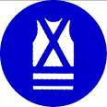
Tasks | Risk | Suggested controls

9. Lighting
A. Are any areas poorly lit, particularly around:  - operational parts of the equipment?  - general work areas and thoroughfares? |  | Yes  No | ❑   | 
Tasks | Risk | Suggested controls

10. Fatigue management
A. Is fatigue likely to be a factor in the operator’s ability to concentrate and work safely (such as through working long hours, unpredictable hours or variable shift rosters)? |  | Yes  No | ❑  
Tasks | Risk | Suggested controls

11. Traffic control
A. Are there likely to be other vehicles or pedestrians in the work area or thoroughfares while the operator is working? |  | Yes  No | ❑   | 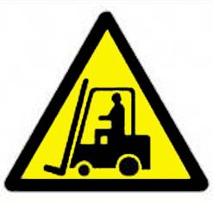
Tasks | Risk | Suggested controls

Sign-off
Name |  | Signature |  | Date

