
Supporting: LMFKB3001A Identify processes in kitchen and bathroom projects

Section 1 Assignment: Trades and services
Name |  | Date

Instructions
The following pieces of equipment are commonly used in kitchen and bathroom installations. For each one, name the item, describe its main purpose, and identify the trade (or trades) that are most likely to use it.

You may submit this assignment to your trainer either by:
- printing out a hard copy posting it in the mail
- saving the file electronically and sending it as an email attachment.

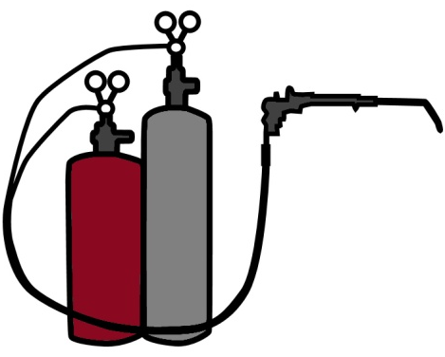 | Name:
 | Main purpose:
 | Trade(s) most likely to use it:

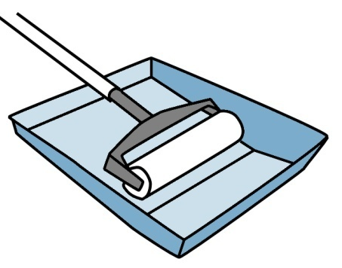 | Name:
 | Main purpose:
 | Trade(s) most likely to use it:

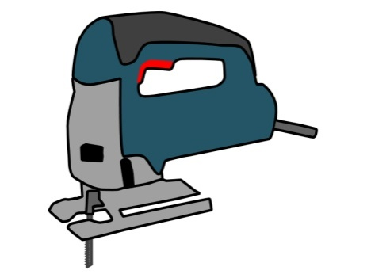 | Name:
 | Main purpose:
 | Trade(s) most likely to use it:

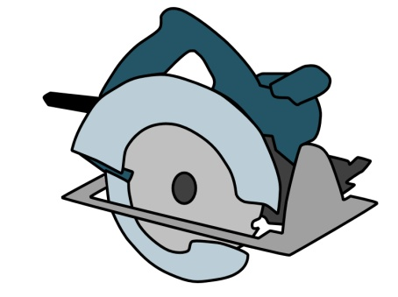 | Name:
 | Main purpose:
 | Trade(s) most likely to use it:

 | Name:
 | Main purpose:
 | Trade(s) most likely to use it:

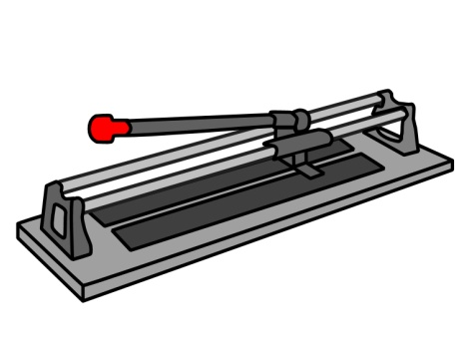 | Name:
 | Main purpose:
 | Trade(s) most likely to use it:

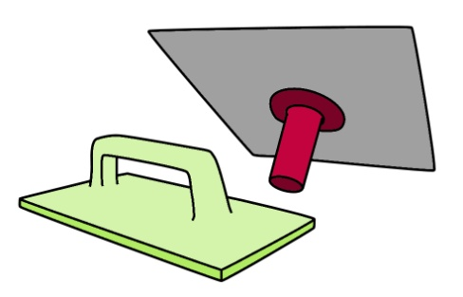 | Name:
 | Main purpose:
 | Trade(s) most likely to use it:

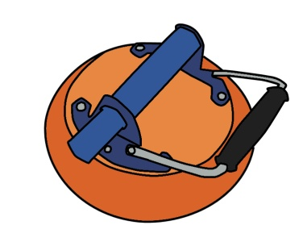 | Name:
 | Main purpose:
 | Trade(s) most likely to use it:

 | Name:
 | Main purpose:
 | Trade(s) most likely to use it:

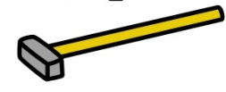  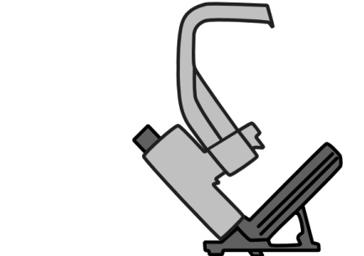 | Name:
 | Main purpose:
 | Trade(s) most likely to use it:

